HI and Distance have multiple constraints with different ranges….

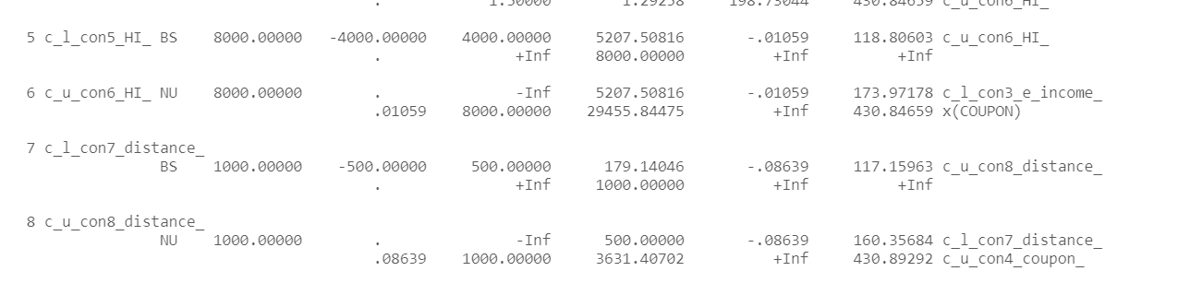

Due to:

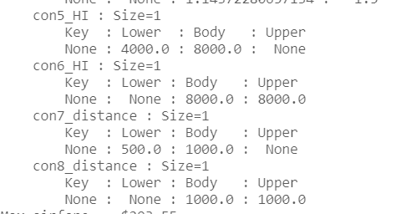

Due to:

M.con5_HI = Constraint(expr=M.x['HI'] >= 4000)

M.con6_HI = Constraint(expr=M.x['HI'] <= 8000)

M.con7_distance = Constraint(expr=M.x['DISTANCE'] >= 500)

M.con8_distance = Constraint(expr=M.x['DISTANCE'] <= 1000)

Variables Have No Bounds on declaration:

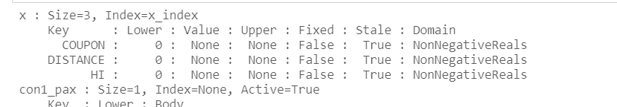

But in my code they do where they are declared:

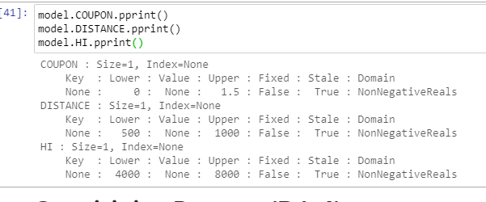

I also seem to be doing the bounds on the variable, not on the sum:

* Example:
  + M.con2_s_income = Constraint(expr=sum(con2_coefs_s_income[p] * M.x[p] for p in predictors) <= 30000)  
    M.con3_e_income = Constraint(expr=sum(con3_coefs_e_income[p] * M.x[p] for p in predictors) >= 30000)
* Versus Mine, where I'm doing the equation elsewhere and my constraint is only on the model value, not the full equation. I'm certain I mis-read something as I was building it and didn't realize my mistake:
  + # model.S_INCOME30000_ct = ConstraintList()  
    # model.S_INCOME30000_ct.add(model.S_INCOME <= 30000)  
      
    # model.E_INCOME30000_ct = ConstraintList()  
    # model.E_INCOME30000_ct.add(model.E_INCOME >= 30000)